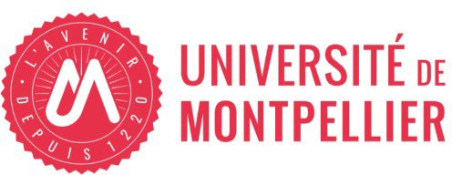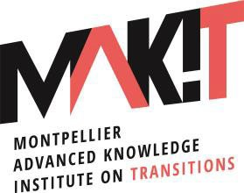

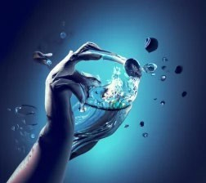
L’humain à l’eau : Human impact on water management and pollution
23-24 April 2024
Montpellier, France

Venue: Charles Flahault auditorium at the Botanical Institute

Day 1 – 23rd April
08:30-08:45 | Registration and welcoming coffee
08:45-09:00 | Opening | Université de Montpellier  Region Occitanie  Patrick Caron (MAK’IT, University of  Montpellier)  Charlotte Boulle (ExposUM)
09:00-09:20 | Introduction | Scientiﬁc Committee: Ramia Al Bakain, Patrick Allard, Filomena Silva
09:20-10:00 | Keynote lecture: Restore the  health of our water | Eric Servat - ICIREWARD (International Center for Interdisciplinary Research on Water Systems Dynamics)
10:00-10:20 | Coﬀee break
10:20-12:30 | Session 1: Plastics in our waters: concerns and future-facing  solutions
10:20-10:30 | Introduction | Filomena Silva
10:30-11:00 | Plastics problematic in the Mediterranean Sea | Elodie Solal (Beyond Plastic Med (BeMed), Monaco)
11:00-11:20 | Micro/nanoplastics: their toxicity in marine organisms and innovative solutions | Miguel Oliveira (CESAM, Portugal)
11:20-11:40 | Biocatalytic membranes for micro/nano plastic degradation within wastewater eﬄuents | Jonas Gurauskis (ARAID, Spain)

11:40-12:20 | Round Table: Towards a more sustainable plastic world: natural recyclability and technical recyclability to reduce plastic pollution | Lucille Chatellard (UMR IATE / Université de Montpellier, France)
 |  | Nathalie Gontard (UMR IATE / Université de Montpellier, France)
 |  | Cristina Nerín (University of Zaragoza, Spain)
 |  | Vincent Colard (CITEO, France)
 |  | François Vasquez (Montpellier Méditerranée Métropole, France)
 |  | Agnès Langevine (Conseil Régional Occitanie, TBC)
12:20-12:30 | Session 1 wrap-up – Filomena Silva
12:30-14:00 | Lunch break
14:00-16:30 | Session 2: Water scarcity management: sustainable approach and pilot projects
14:00-14:10  14:10-15:15  15:15-16:20 | Panel#1  Panel#2 | Mouïn Hamzé, Scientific Advisor of CIHEAM Bari, Italy Moderator  Introductory Statement; Water and Climate Change: Challenges for the Mediterranean Agricultural and Food Systems.  Water Management: Scarcity, Pollution, and Impact on Climate Change  - Patrick Lachassagne, HydroSciences Montpellier, Univ; Montpellier, CNRS, IRD, IMT Mines Alès, Montpellier.  ‘’Water resources scarcity due to global change, Challenges and solutions’’  - Elena Gomez, HydroSciences Montpellier (Univ. of Montpellier, CNRS, IRD).  ‘’Chemical diversity and the role of analytical capabilities in characterizing water contamination’’  - Geoffroy Duporte, HydroSciences Montpellier (Univ. Montpellier, CNRS, IRD).  ‘’ Evaluation of emerging contaminant removal processes during artificial recharge through a reactive barrier: from laboratory experiments to field application’’.  - Valentina Mereu, Institute for Climate Resilience, Impacts on Agriculture, Forests and Ecosystem Services Division of the Euro-Mediterranean Center on Climate Change (CMCC) Foundation, Italy.  ‘’Irrigation needs and water management in the context of climate change’’  DISCUSSION  Research, Innovation and Geopolitical Chalenges of Water in the Mediterranean Region  - Giuseppe Provenzano, Manager Higher Education and Research, Union for the Mediterranean (UFM).  ‘Research and innovation to face challenges on Climate Change and its impact in the food system of the Mediterranean region’  - Pierre Blanc, Professor of Geopolitics, Sciences po Bordeaux and Bordeaux sciences agro, Researcher at LAM (CNRS/Sciences po Bordeaux).  ‘Water Scarcity and climate change: geopolitics and politics issues'  - Fethi Laachal, Georesources Laboratory, Water Research and Technology Centre, Tunisia.  ‘’Adapting treated wastewater reuse face to global and climate changes in water scarcity regions: experience of groundwater artificial recharge and irrigation in Tunisia’’.  - Nassim Ait Mouheb, INRAE - UMR G-EAU.  Water Reuse in Algerian Oasis Region: Institutional Management Bottlenecks and Demonstration of Operational Feasibility.  DISCUSSION
16:20-16:30 | Session 2 wrap-up - Ramia Al Bakain
16:30-17:30 | Plastic-free cocktail
Day 2 – 24th April
8:30-9:00
9:00-12:00 | Session 3: Our future with “forever” contaminants
9:00-9:10 | Session intro | Patrick Allard
9:10-09:50 | Overview and update on PFAS  chemicals and their toxicity | Sue Fenton (Center for Human Health and the Environment (CHHE) - North Carolina State University, USA)
09:50-10:30 | Prevalence of PFAS in the ecosystem | Mathieu Ben Braham (Generations Futures)
10:30-11:00 | Coffee break
11:00-11:40 | PFAS in Europe, water, and  regulation | Jelena Prtorić (Troubled Waters Project)
11:40-11:50 | A contaminated future? The concerns of the environment and the epigenome. | Giacomo Cavalli (Institut de génétique humaine – CNRS / Université de Montpellier)
11:50-12:00 | General discussion and session wrap-up – Patrick Allard
12:00-12:30 | Take home messages and  conference closing | Scientiﬁc committee and Patrick Caron

Day 2 – 24th April workshop
14:00-17:00 | Drafting of white paper (specific topics to be included, structure of the paper, deciding on set of recommendations) | Discretional participation

